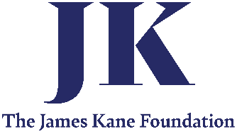
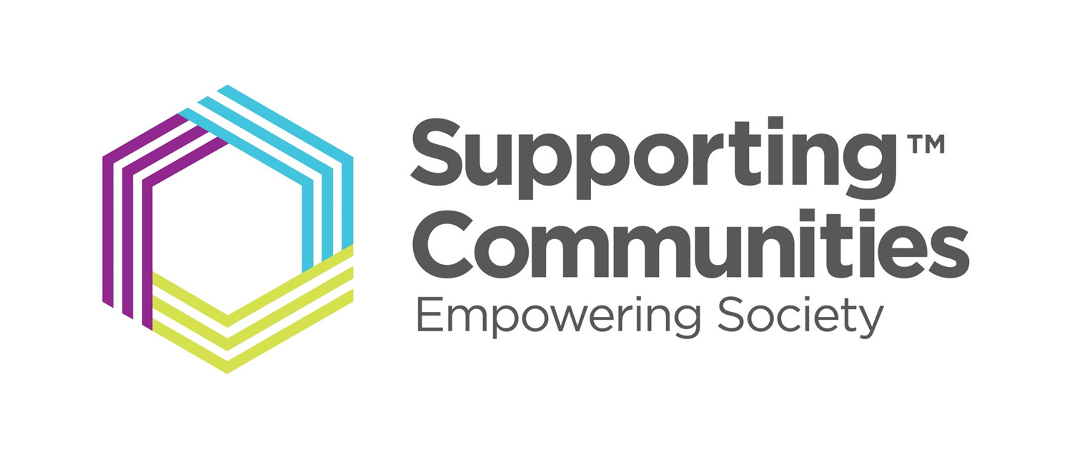

Dear student,
Supported by The James Kane Foundation, Supporting Communities is pleased to offer a new scholarship programme for Year 14 (Upper 6th) students attending one of the qualifying schools, living in the Armagh, Banbridge & Craigavon Council (ABC) area and hoping to attend university in Northern Ireland this September.
PLEASE READ THE FOLLOWING CAREFULLY. APPLICATIONS WHICH DO NOT MEET THE REQUIREMENTS WILL NOT BE CONSIDERED.
The Fund is for Year 14 (upper 6th form) students in ABC who are applying to Queens or Ulster University this year to study STEM (Science, Technology, Engineering, Mathematics) degrees. Unfortunately, degrees outside of STEM cannot be considered for the scholarship.
How much could I get?
If successful, you will receive £2,000 per year of your course up to a maximum of three years (£6,000 in total).
Application process
The Scholarship operates a two-tier application process. Firstly, you must complete the online or attached application form and return it, confirming you meet the criteria. A panel will screen the applications and then invite no more than six students to interview with a maximum of two being selected for the scholarship. It is anticipated the interviews will take place in August 2023 in person. * The two successful applicants will be informed before/at the start of September 2023. It is important to note that Information given by applicants relating to the essential criteria will be checked for accuracy and as such proof may need to be provided by the applicant. By submitting an application, you are confirming that you and your parent(s) / guardian are happy to do so.
Conditions for applications
Applicants must meet all the following conditions:
- Be aged 18+ by or on 30th June 2023
- Are attending one of the following schools as a Year 14 A level student:
- Lismore Comprehensive,
- St Ronan's College,
- Lurgan College,
- Portadown College.
- Any school in the Banbridge Area Learning Community,
- Any school in the Armagh Area Learning Community,
- Southern Regional College.

- Live permanently at an address in the Armagh, Banbridge & Craigavon Council Area.
- Intend to study at either Ulster University or Queens University commencing September/October 2023.
- Intend to study a STEM degree. STEM degrees will be considered under the relevant Schools as detailed below:
Ulster University
- School of Engineering
- School of Computing
- School of Computing, Engineering and Intelligent Systems
- School of Biomedical Sciences
- School of Geography and Environmental Sciences
Queens University
- Planning, Architecture and Civil Engineering;
- Biomedical Sciences (not medicine or dentistry)
- Chemistry and Chemical Engineering;
- Electronics, Electrical Engineering and Computer Science;
- Mathematics and Physics;
- Mechanical and Aerospace Engineering.
Applicants must also meet at least one of the following criteria:
- Parent(s) are in receipt of Universal Credit
- Live in social housing (NIHE or Housing Association tenant) or in a recognised social housing area
- Live in a household with a single parent/guardian
- Have a combined household income under £40,000.00 per annum
- Do not live with or are not supported by a parent
How to apply
Applications must be submitted by 5pm on Friday, 21st July 2023. To apply please follow the link below to our online application, scroll to the bottom of the page and click ‘Open Form’ (preferrable method of application).
https://supportingcommunities.org/james-kane-foundation-scholarship
Alternatively, you can complete the application form below and send it to stephen@supportingcommunities.org.
Finally, may I take this opportunity to wish you all the best in your upcoming exams.
Kind Regards
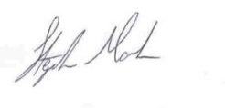
P.s. If you have any queries about the process of application, please contact: Stephen Marks, stephen@supportingcommunities.org *Supporting Communities reserve the right to carry out interviews via Zoom.
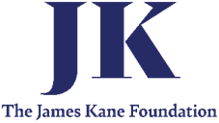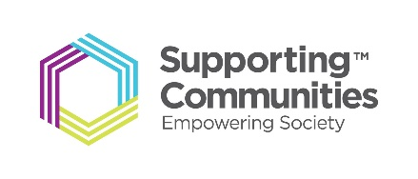

The James Kane Foundation
SCHOLARSHIP APPLICATION FORM

This application form is for second year A Level student’s (Year 14) preparing to attend University in Northern Ireland i.e., Ulster University or Queens University commencing studies in September/October 2023. Only complete this form if you meet all the criteria in section A below and at least one of the criteria in Section B.

If you wish you can complete this form online at: https://supportingcommunities.org/james-kane-foundation-scholarship

All the information given within this application form will be treated with the strictest confidence in line with the Data Protection Act 2018 and will not be used with any other purpose than that for which it is given. https://supportingcommunities.org/privacy-notice

If you have any queries about the process of application, please contact:
- Stephen Marks, Supporting Communities stephen@supportingcommunities.org

Section A

Please confirm that you meet the following criteria (only students meeting ALL the criteria in this section need apply).

☐ By ticking this box I confirm that I will be aged 18+ by or on 30th June 2023.

☐ I attend one of the following schools as a Year 14 A level student:

- Lismore Comprehensive,
- St Ronan's College,
- Lurgan College,
- Portadown College,
- Any school in the Banbridge Area Learning Community,
- Any school in the Armagh Area Learning Community,
- Southern Regional College.

☐ I live permanently at an address in Armagh, Banbridge & Craigavon Council Area.

☐ I intend to study at either Ulster University or Queens University commencing September/October 2023.

☐ I intend to study a STEM degree.

Section B

Please confirm that you meet at least one of the following criteria (select all that apply)

☐ Parent(s) are in receipt of Universal Credit
☐ I live in social housing (NIHE or Housing Association tenant) or in a recognised social housing area
☐ I live in a household with a single parent/guardian
☐ Combined household income under £40,000.00 per annum
☐ I am not living with or supported by my parent(s)

Applicant Details

Full Name (Mr/Mrs/Miss/Ms):
Home Address:
Postcode:
Telephone Number:
Mobile Number:
E-mail:

Current School:
University applied to:
Degree course applied for:
Predicted ‘A’ Level Grades: | Subject: Grade:
 | Subject: Grade:
 | Subject: Grade:
 | Subject: Grade:

University School that my intended Degree is related to:

Ulster University
- School of Engineering ☐
- School of Computing ☐
- School of Computing, Engineering and Intelligent Systems ☐
- School of Biomedical Sciences ☐
- School of Geography and Environmental Sciences ☐
Queens University
- Planning, Architecture and Civil Engineering; ☐
- Biomedical Sciences (not medicine or dentistry) ☐
- Chemistry and Chemical Engineering; ☐
- Electronics, Electrical Engineering and Computer Science; ☐
- Mathematics and Physics; ☐
- Mechanical and Aerospace Engineering. ☐

Educational Background: Please give a brief description of any qualifications you currently have.

Subject Grade

Personal Background: Please tell us about YOU (your interests, hobbies, challenges, and successes. MAX 500 words)

Confirmation

By signing this form, I confirm that all information given is accurate and I understand that submission of this form does not constitute an offer of financial support from the related fund or Supporting Communities.

☐ If my application is progressed to the next stage, I will consent to attend an interview.

☐ If successful at interview, I consent to take part in all future fund related / Supporting Communities publications, related to the Scholarship, for marketing/advertising purposes.

Signed: _______________________________________________________

Date: ________________________________

NOTE: Additional information is available on the Supporting Communities website: www.supportingcommunities.org

Please return this application by e-mail to: |  | stephen@supportingcommunities.org
Closing date for applications: | 5pm 21st July 2023
Interviews to be held: August 2023

NOTE: Interviews may be conducted using a digital platform such as Zoom or Teams
Information given by applicants relating to the essential criteria will be checked for accuracy and as such proof may need to be provided by the applicant. By submitting this application, you are confirming that you and your parent(s) / guardian are happy to do so.

This programme is Supported by The James Kane Foundation and administered by Supporting Communities.

